USB CAN module use gs_usb.ko driver along with official Linux kernel , enable gs_usb driver

In kernel menuconfig and install the gs_usb.ko to your system.

Kernel config :



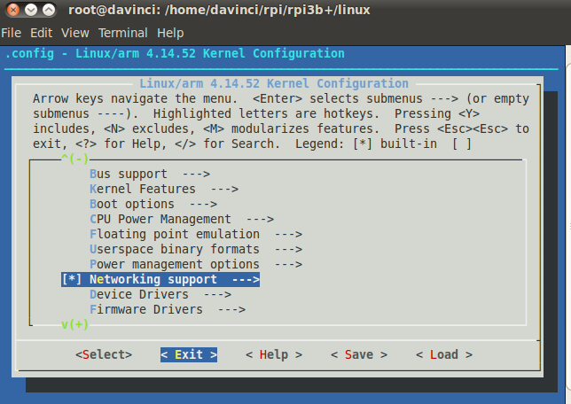

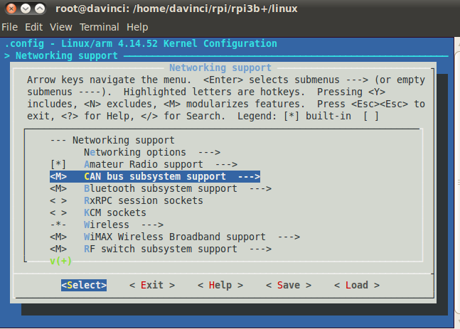

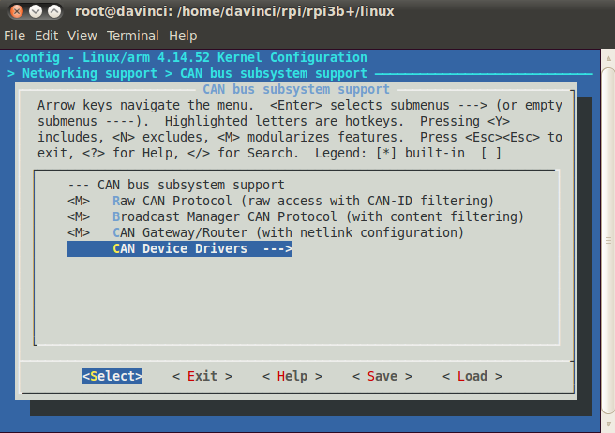

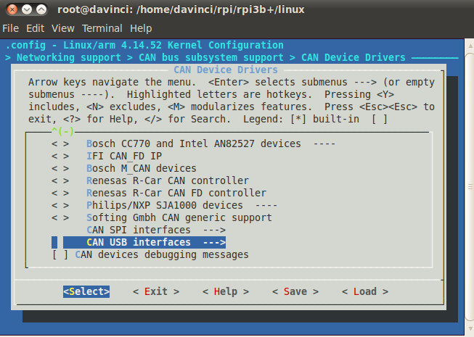

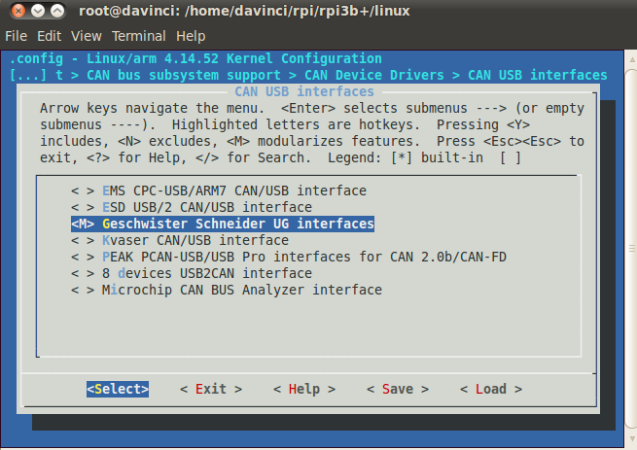

And then make the kernel,Please refer to the build kernel method on different platform

Raspberry Pi 4:

make ARCH=arm CROSS_COMPILE=arm-linux-gnueabihf- zImage modules dtbs -j4